Grace PIR Motion Sensor

FEATURES:
- Instant Notification based on motion.

DAIS:
Device:
{
"_id": "100035e0",
"deviceTypeId": "ezlopi",
"parentDeviceId": "",
"category": "generic_sensor",
"subcategory": "motion",
"gatewayId": "457a5069",
"batteryPowered": false,
"name": "Grace PIR",
"serviceNotification": false,
"type": "sensor",
"reachable": true,
"roomId": "",
"security": "no",
"ready": true,
"status": "idle"
}

Items:
{
"_id": "200035f6",
"deviceId": "100035f0",
"hasGetter": true,
"hasSetter": false,
"name": "motion",
"valueType": "bool",
"value": true,
"valueFormatted": true
}

{
"_id": "200035f6",
"deviceId": "100035f0",
"hasGetter": true,
"hasSetter": false,
"enum:[
"battery_maintenance_ok",
"replace_battery_soon",
"replace_battery_now",
"battery_fluid_is_low",
"unknown"
]
"name": "battery_maintenance_state",
"valueType": "token",
"value": "battery_maintenance_ok",
"valueFormatted": "battery_maintenance_ok"
}

PICTURES:
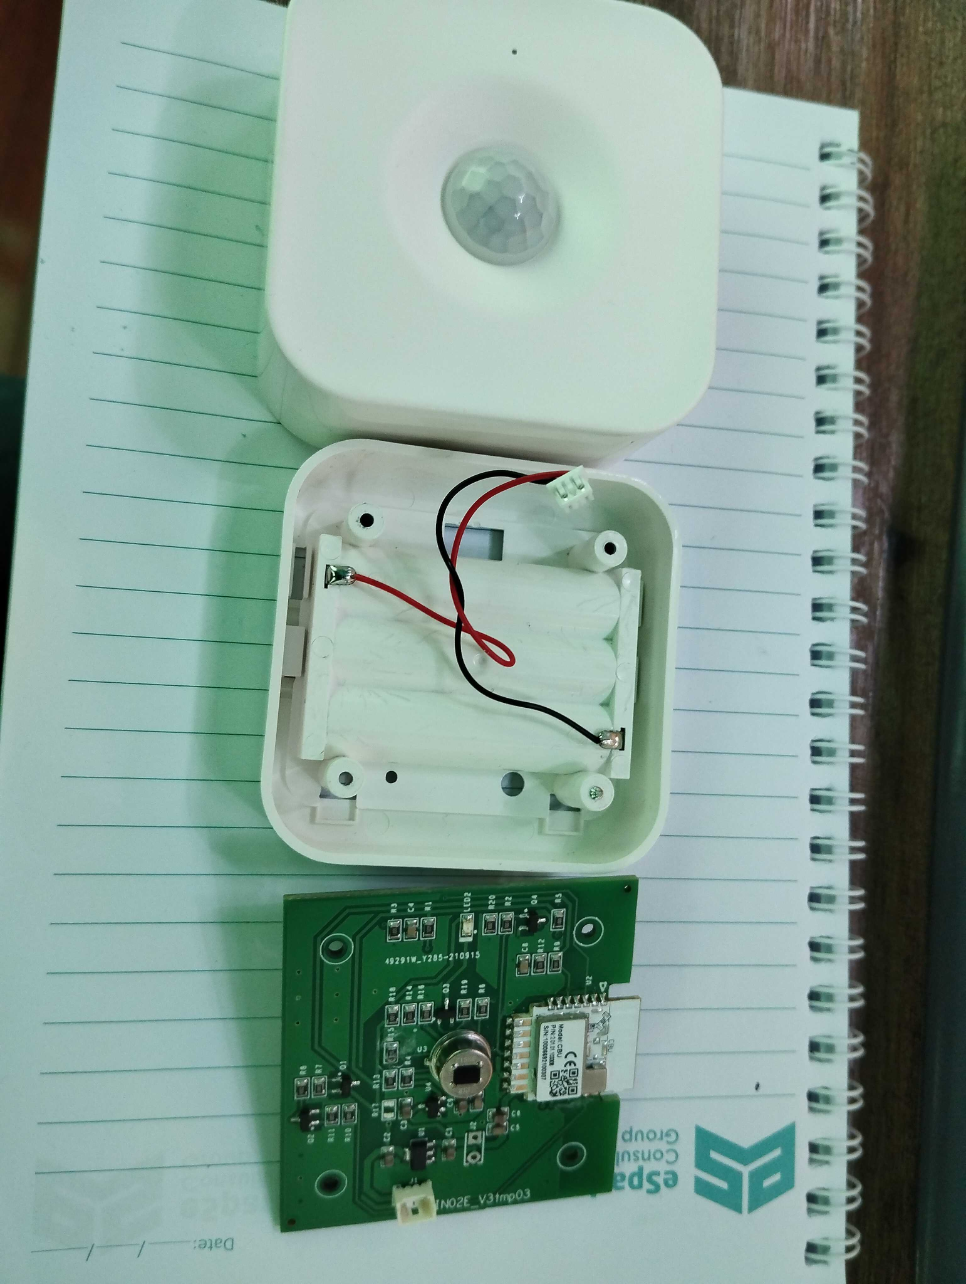
Device Inside View
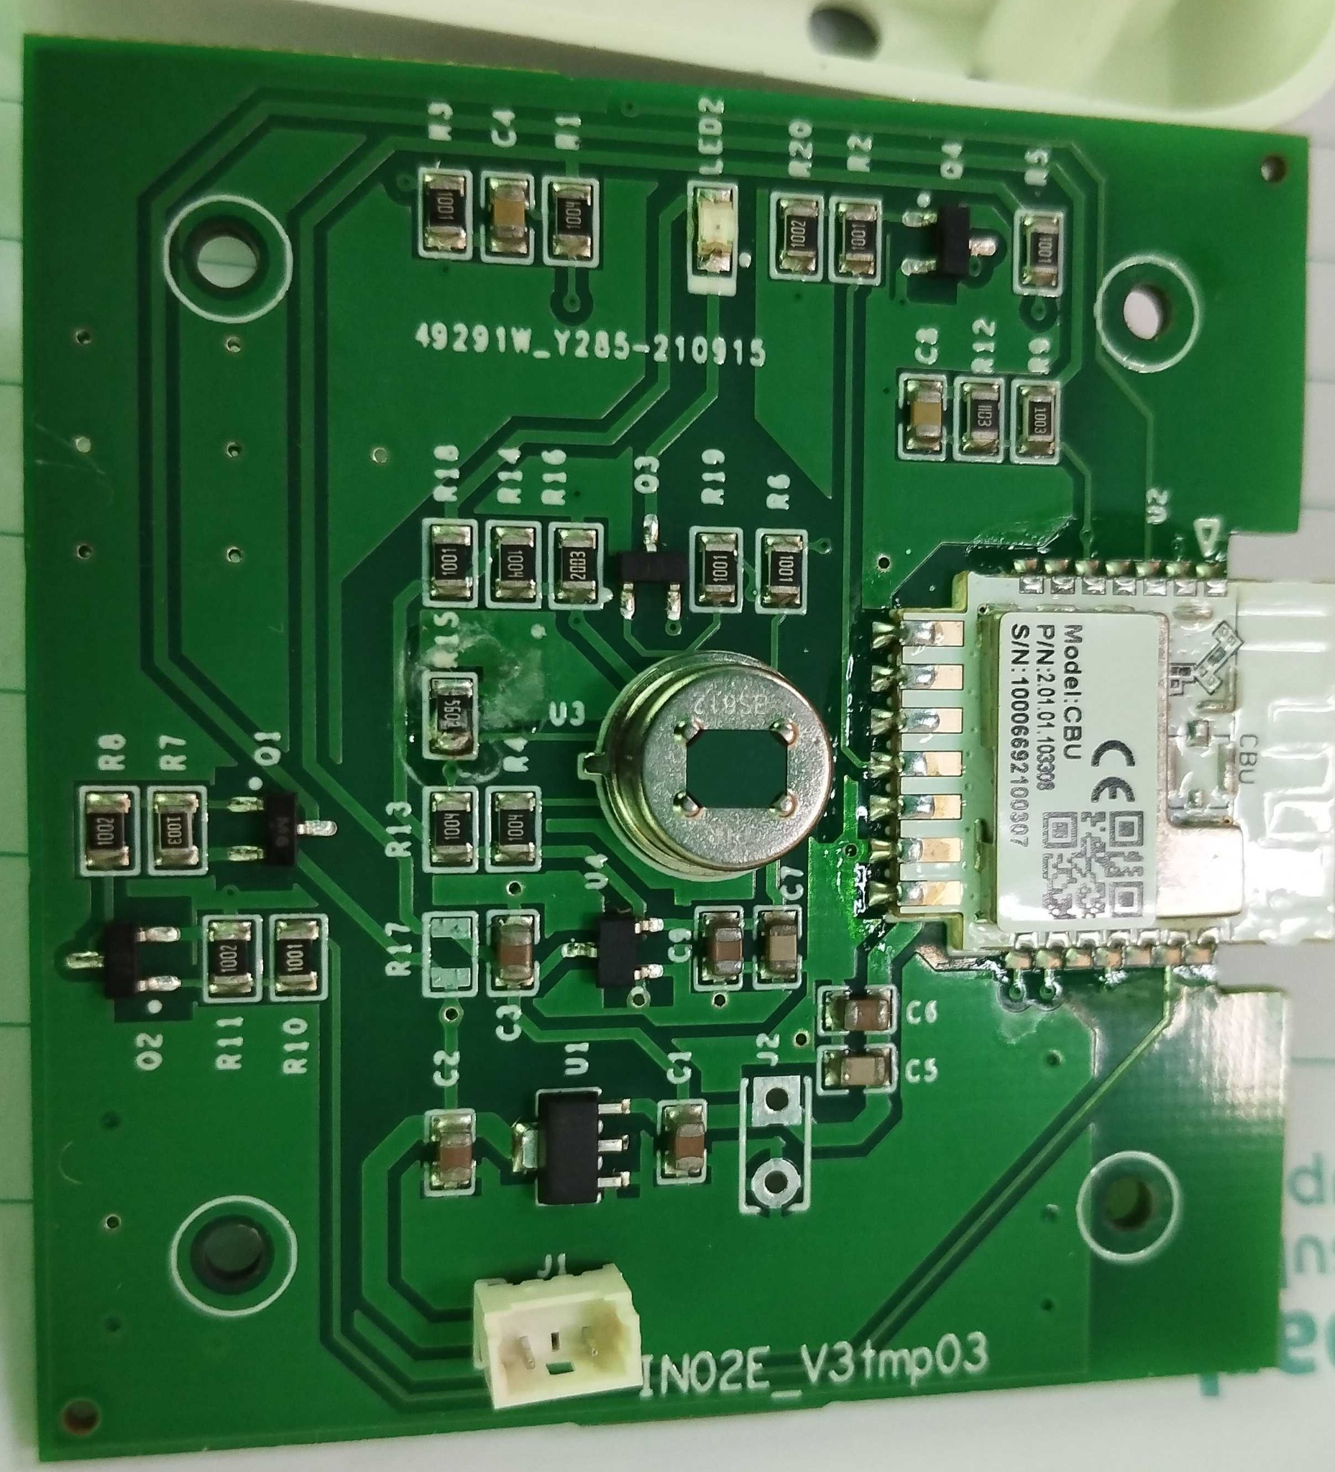
PCB Front View
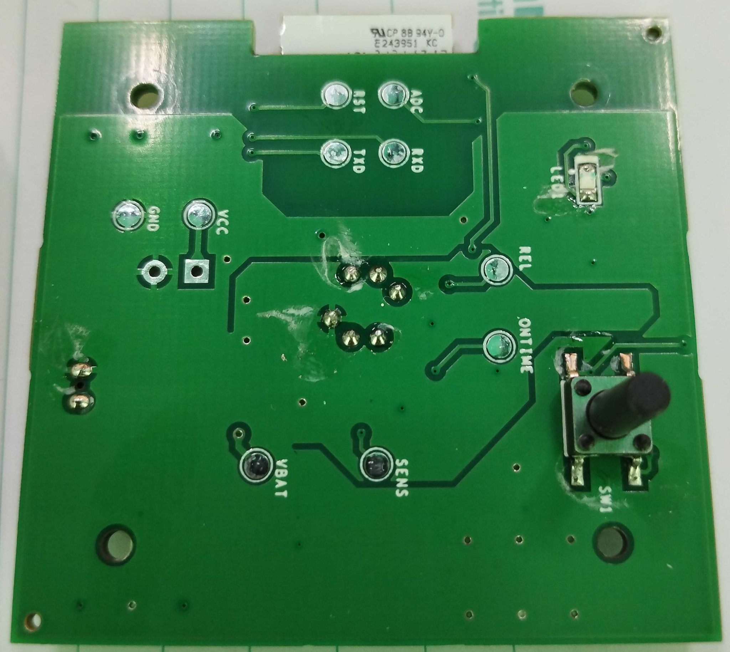
PCB Back View

